A Smart Initiation Kit for Engineers in Agriculture
CHAPTER1(INTRODUCTION):
Abstract
The project “A Smart Initiation Kit for Engineers in Agriculture Using IoT and Machine Learning” focuses on developing an intelligent, data-driven agricultural monitoring system using the ESP32 microcontroller integrated with a soil moisture sensor, humidity sensor, and water level sensor. The system continuously collects environmental data such as soil moisture content, ambient humidity, and water level. These readings are processed and analyzed using Machine Learning algorithms to predict soil conditions, irrigation needs, and potential environmental variations affecting crop growth.
The ESP32’s built-in Wi-Fi module enables real-time data transmission to the cloud or a mobile application for remote access. Using ML models, the system can learn from previous sensor data and make intelligent predictions — such as identifying dry soil conditions, recommending irrigation timing, and detecting abnormal humidity patterns. This helps farmers optimize water use, improve yield, and ensure sustainable farming practices.
This smart agricultural kit acts as a learning and experimental platform for engineers, blending IoT and ML technologies to create a foundation for smart farming and precision agriculture. It offers a cost-effective, scalable, and innovative solution to modern agricultural challenges.

Introduction
Agriculture plays a vital role in sustaining the world’s economy and food supply, but traditional farming methods often face challenges such as unpredictable weather, improper irrigation, and inefficient use of resources. With the advancement of technology, smart agriculture has emerged as a promising approach to overcome these issues by integrating Internet of Things (IoT) and Machine Learning (ML) technologies.
This project, titled “A Smart Initiation Kit for Engineers in Agriculture”, aims to provide a practical and innovative platform for agricultural monitoring and decision-making. The system is built around the ESP32 microcontroller, which serves as the core unit for data collection and communication. Sensors such as soil moisture, humidity, and water level sensors are used to gather essential environmental parameters that directly affect crop growth and soil health.
Using IoT connectivity, the collected data is transmitted to a cloud server or mobile application, allowing users to monitor field conditions in real time. The integration of Machine Learning algorithms enables the system to analyze patterns, predict soil moisture levels, estimate irrigation requirements, and identify abnormal humidity or water level changes.
This smart initiation kit serves as a learning tool for engineers and students, promoting innovation in precision agriculture. It not only enhances efficiency and productivity but also supports sustainable resource management, helping farmers make data-driven decisions for better crop yields and reduced wastage.

Problem Statement
Traditional agricultural practices heavily depend on manual observation and farmer experience to determine irrigation needs, humidity effects, and soil conditions. This approach often leads to over-irrigation or under-irrigation, wastage of water, and reduced crop productivity due to the lack of accurate, real-time data. Moreover, changing climate conditions make it difficult for farmers to predict environmental variations that affect soil and crop health.
There is a growing need for a smart, automated, and data-driven system that can monitor environmental parameters continuously and provide intelligent insights to assist farmers in making timely and efficient decisions. The main problem lies in the absence of a low-cost, easy-to-use platform that combines IoT-based sensing with Machine Learning analysis for effective agricultural management.
This project addresses these challenges by developing a Smart Initiation Kit using ESP32, various environmental sensors, and Machine Learning algorithms. The system is designed to predict irrigation needs, monitor humidity variations, and manage water levels intelligently. This provides an efficient and scalable solution for improving crop health, conserving water, and supporting sustainable agriculture.

Objectives
- To develop a smart agriculture system using ESP32 and different sensors.
- To measure soil moisture, humidity, and water level in real time.
- To use Machine Learning for predicting irrigation needs and soil conditions.
- To send data to a mobile app or cloud for easy remote monitoring.
- To help farmers save water and improve crop growth using data-based decisions.
- To make a low-cost and easy-to-use kit for students and engineers.
- To encourage learning and innovation in smart and sustainable farming.

Literature Review
Many researchers and engineers have worked on using IoT and sensors to make farming smarter and more efficient. Traditional farming methods often depend on human observation, which can lead to mistakes in irrigation and crop care. Recent studies show that IoT-based systems can collect real-time data from farms using microcontrollers like Arduino, Raspberry Pi, or ESP32 and sensors such as soil moisture, temperature, and humidity sensors. These systems help farmers make better decisions about watering and weather conditions.
Some projects have used cloud platforms and mobile apps to allow farmers to check their farm data remotely. This makes monitoring easier and saves time. Researchers have also started using Machine Learning (ML) to analyze the collected data and make predictions. ML can forecast soil dryness, suggest irrigation timing, and detect unusual environmental patterns.
Studies show that combining IoT with ML gives better results than using only sensors. It helps in predictive farming, where farmers can act before a problem occurs. Many papers highlight that ESP32 is a powerful and low-cost controller for IoT projects because it has built-in Wi-Fi and supports multiple sensors.
From these research works, it is clear that an integrated system using ESP32, IoT sensors, and ML algorithms can greatly improve agricultural productivity, resource management, and sustainability.

CHAPTER2(RELATED WORK):
Arduino IDE:
The Arduino Integrated Development Environment or Arduino Software (IDE) - contains a text editor for writing code, a message area, a text console, a toolbar with buttons for common functions and a series of menus. It connects to the Arduino hardware to upload programs and communicate with them.
Programs written using Arduino Software (IDE) are called sketches. These sketches are written in the text editor and are saved with the file extension. ino. The editor has features for cutting/pasting and for searching/replacing text. The message area gives feedback while saving and exporting and also displays errors. The console displays text output by the Arduino Software (IDE), including complete error messages and other information. The bottom right-hand corner of the window displays the configured board and serial port. The toolbar buttons allow you to verify and upload programs, create, open, and save sketches, and open the serial monitor.
If you aim to download the Windows app version, make sure you have Windows 8.1 or Windows 10, as the app version is not compatible with Windows 7 or older version of this operating system.
The IDE environment is mainly distributed into five sections
- File
- Edit
- Sketch
- Tools
- Help

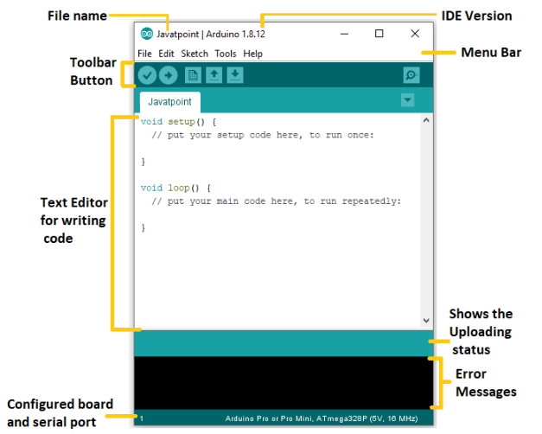

File:

- New Creates a new instance of the editor, with the bare minimum structure of a sketch already in place.
- Open Allows to load a sketch file browsing through the computer drives and folders.
- Open Recent Provides a short list of the most recent sketches, ready to be opened.
- Sketchbook Shows the current sketches within the sketchbook folder structure; clicking on any name opens the corresponding sketch in a new editor instance.
- Examples Any example provided by the Arduino Software (IDE) or library shows up in this menu item. All the examples are structured in a tree that allows easy access by topic or library.
- Close Closes the instance of the Arduino Software from which it is clicked.
- Save Saves the sketch with the current name. If the file hasn't been named before, a name will be provided in a "Save as." window.
- Save as... Allows to save the current sketch with a different name.
- Page Setup It shows the Page Setup window for printing.
- Print Sends the current sketch to the printer according to the settings defined in Page Setup.
- Preferences Opens the Preferences window where some settings of the IDE may be customized, as the language of the IDE interface.
- Quit Closes all IDE windows. The same sketches open when Quit was chosen will be automatically reopened the next time you start the IDE.

Edit
- Undo/Redo Goes back of one or more steps you did while editing; when you go back, you may go forward with Redo.
- Cut Removes the selected text from the editor and places it into the clipboard.
- Copy Duplicates the selected text in the editor and places it into the clipboard.
- Copy for Forum Copies the code of your sketch to the clipboard in a form suitable for posting to the forum, complete with syntax coloring.
- Copy as HTML Copies the code of your sketch to the clipboard as HTML, suitable for embedding in web pages.
- Paste Puts the contents of the clipboard at the cursor position, in the editor.
- Select All Selects and highlights the whole content of the editor.
- Comment/Uncomment Puts or removes the // comment marker at the beginning of each selected line.
- Increase/Decrease Indent Adds or subtracts a space at the beginning of each selected line, moving the text one space on the right or eliminating a space at the beginning.
- Find Opens the Find and Replace window where you can specify text to search inside the current sketch according to several options.
- Find Next Highlights the next occurrence - if any - of the string specified as the search item in the Find window, relative to the cursor position.
- Find Previous Highlights the previous occurrence - if any - of the string specified as the search item in the Find window relative to the cursor position.

Sketch

- Verify/Compile Checks your sketch for errors compiling it; it will report memory usage for code and variables in the console area.
- Upload Compiles and loads the binary file onto the configured board through the configured Port.
- Upload Using Programmer This will overwrite the bootloader on the board; you will need to use Tools > Burn Bootloader to restore it and be able to Upload to USB serial port again. However, it allows you to use the full capacity of the Flash memory for your sketch. Please note that this command will NOT burn the fuses. To do so a Tools -> Burn Bootloader command must be executed.
- Export Compiled Binary Saves a .hex file that may be kept as archive or sent to the board using other tools.
- Show Sketch Folder Opens the current sketch folder.
- Include Library Adds a library to your sketch by inserting #include statements at the start of your code.
- Additionally, from this menu item you can access the Library Manager and import new libraries from .zip files.
- Add File... Adds a supplemental file to the sketch (it will be copied from its current location). The file is saved to the data subfolder of the sketch, which is intended for assets such as documentation. The contents of the data folder are not compiled, so they do not become part of the sketch program.

Tools

- Auto Format This formats your code nicely: i.e. indents it so that opening and closing curly braces line up, and that the statements inside curly braces are indented more.
- Archive Sketch Archives a copy of the current sketch in .zip format. The archive is placed in the same directory as the sketch.
- Fix Encoding & Reload Fixes possible discrepancies between the editor char map encoding and other operating systems char maps.
- Serial Monitor Opens the serial monitor window and initiates the exchange of data with any connected board on the currently selected Port. This usually resets the board, if the board supports Reset over serial port opening.
- Board Select the board that you're using.
- Port This menu contains all the serial devices (real or virtual) on your machine. It should automatically refresh every time you open the top-level tools menu.
- Programmer For selecting a hardware programmer when programming a board or chip and not using the onboard USB-serial connection.
- Burn Bootloader The items in this menu allow you to burn a bootloader onto the microcontroller on an Arduino board. This is not required for normal use of an Arduino board but is useful if you purchase a new ATmega microcontroller (which normally come without a bootloader). Ensure that you've selected the correct board from the Boards menu before burning the bootloader on the target board. This command also set the right fuses.

Help

Here you find easy access to a number of documents that come with the Arduino Software (IDE). You have access to Getting Started, Reference, this guide to the IDE and other documents locally, without an internet connection. The documents are a local copy of the online ones and may link back to our online website.
- Find in Reference This is the only interactive function of the Help menu: it directly selects the relevant page in the local copy of the Reference for the function or command under the cursor.

Sketchbook of Arduino IDE:
The Arduino Software (IDE) uses the concept of a sketchbook: a standard place to store your programs (or sketches). The sketches in your sketchbook can be opened from the File > Sketchbook menu or from the Open button on the toolbar. The first time you run the Arduino software; it will automatically create a directory for your sketchbook. You can view or change the location of the sketchbook location from with the Preferences dialog. Beginning with version 1.0, files are saved with a .ino file extension. Previous versions use the. pde extension. You may still open. pde named files in version 1.0 and later, the software will automatically rename the extension to. ino.

Tabs, Multiple Files, and Compilation of Arduino IDE:
Allows you to manage sketches with more than one file (each of which appears in its own tab). These can be normal Arduino code files (no visible extension), C files (.c extension), C++ files (.cpp), or header files (.h).
Before compiling the sketch, all the normal Arduino code files of the sketch (. ino,. pde) are concatenated into a single file following the order the tabs are shown in. The other file types are left as is.
Uploading of code in Arduino IDE:
Before uploading your sketch, you need to select the correct items from the Tools > Board and Tools > Port menus. The boards are described below. On the Mac, the serial port is probably something like /dev/tty. usbmodem241 (for an UNO or Mega2560 or Leonardo) or /dev/tty.usbserial-1B1 (for a Duemilanove or earlier USB board), or /dev/tty. USA19QW1b1P1.1 (for a serial board connected with a Keyspan USB-to-Serial adapter). On Windows, it's probably COM1 or COM2 (for a serial board) or COM4, COM5, COM7, or higher (for a USB board) - to find out, you look for USB serial device in the ports section of the Windows Device Manager. On Linux, it should be /dev/ttyACMx , /dev/ttyUSBx or similar. Once you've selected the correct serial port and board, press the upload button in the toolbar or select the Upload item from the Sketch menu. Current Arduino boards will reset automatically and begin the upload. With older boards (pre-Diecimila) that lack auto-reset, you'll need to press the reset button on the board just before starting the upload. On most boards, you'll see the RX and TX LEDs blink as the sketch is uploaded. The Arduino Software (IDE) will display a message when the upload is complete, or show an error.
When you upload a sketch, you're using the Arduino bootloader, a small program that has been loaded on to the microcontroller on your board. It allows you to upload code without using any additional hardware. The bootloader is active for a few seconds when the board resets; then it starts whichever sketch was most recently uploaded to the microcontroller. The bootloader will blink the on-board (pin 13) LED when it starts (i.e. when the board resets).

Libraries of Arduino IDE:
Libraries are very useful for adding the extra functionality into the Arduino Module. There is a list of libraries can add by clicking the Sketch button in the menu bar and going to Include Library.
Libraries provide extra functionality for use in sketches, e.g. working with hardware or manipulating data. To use a library in a sketch, select it from the Sketch > Import Library menu. This will insert one or more #include statements at the top of the sketch and compile the library with your sketch. Because libraries are uploaded to the board with your sketch, they increase the amount of space it takes up. If a sketch no longer needs a library, simply delete its #include statements from the top of your code.
There is a list of libraries in the reference. Some libraries are included with the Arduino software. Others can be downloaded from a variety of sources or through the Library Manager. Starting with version 1.0.5 of the IDE, you do can import a library from a zip file and use it in an open sketch. See these instructions for installing a third-party library.
Most of the libraries are preinstalled and come with the Arduino software. However, we can also download them from external source. To install a new library into your Arduino IDE you can use the Library Manager Open the IDE and click to the "Sketch" menu and then Include Library > Manage Libraries.

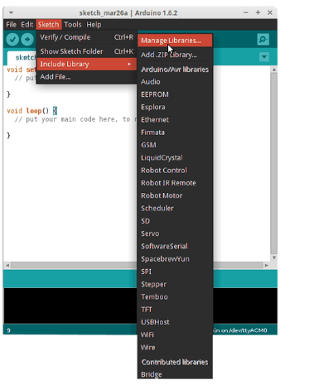

Then the Library Manager will open and you will find a list of libraries that are already installed or ready for installation. In this example we will install the Bridge library. Scroll the list to find it, click on it, then select the version of the library you want to install. Sometimes only one version of the library is available. If the version selection menu does not appear, don't worry: it is normal.

Finally click on install and wait for the IDE to install the new library. Downloading may take time depending on your connection speed. Once it has finished, an Installed tag should appear next to the Bridge library. You can close the library manager.

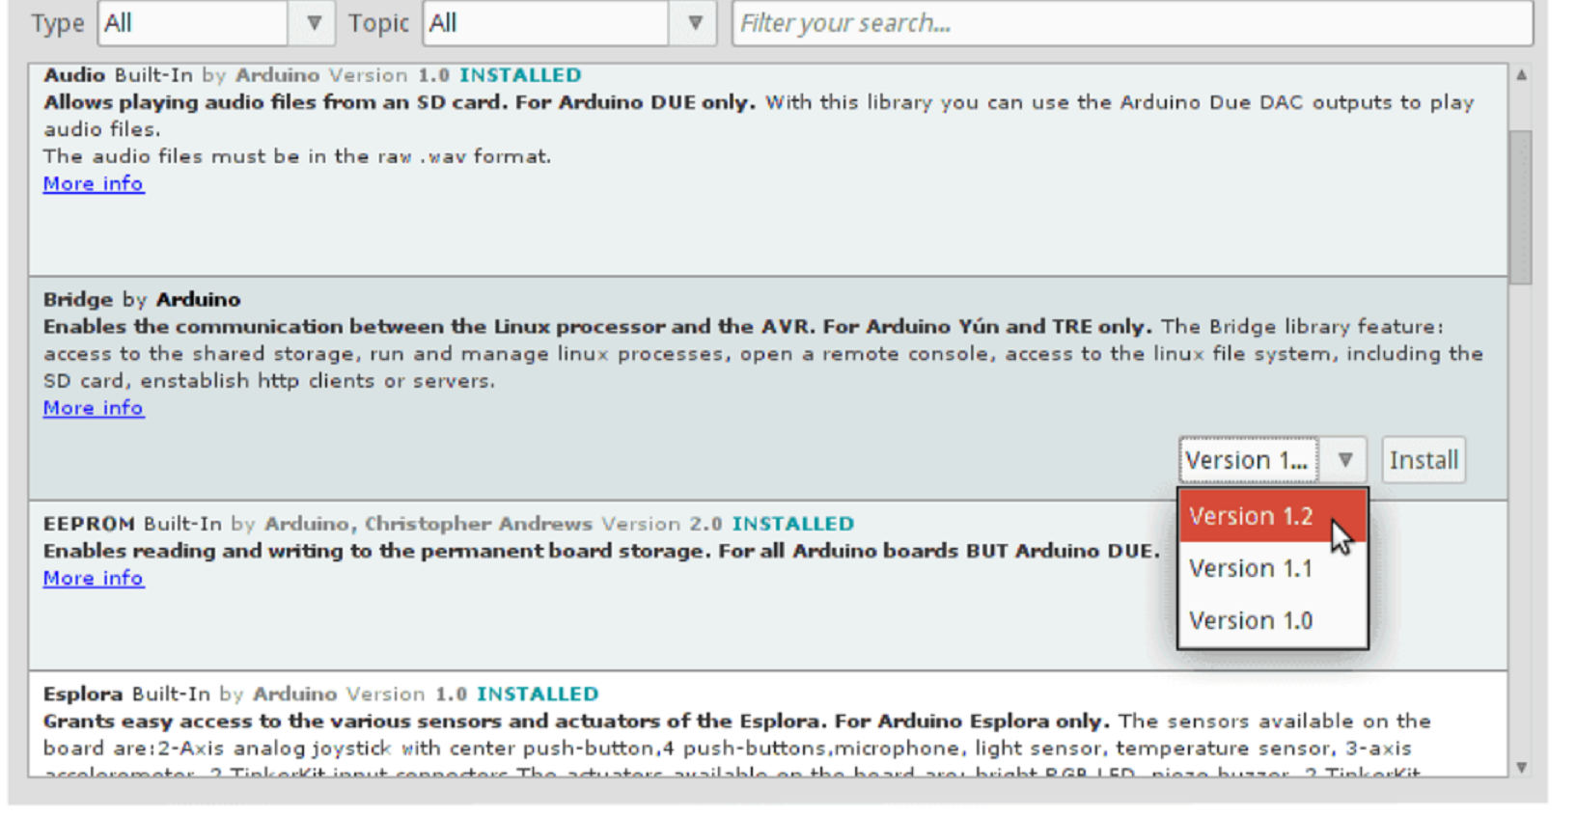

Importing a .zip Library in Arduino IDE:
Libraries are often distributed as a ZIP file or folder. The name of the folder is the name of the library. Inside the folder will be a .cpp file, a .h file and often a keywords.txt file, examples folder, and other files required by the library. Starting with version 1.0.5, you can install 3rd party libraries in the IDE. Do not unzip the downloaded library, leave it as is.
In the Arduino IDE, navigate to Sketch > Include Library > Add .ZIP Library. At the top of the drop-down list, select the option to "Add .ZIP Library''.

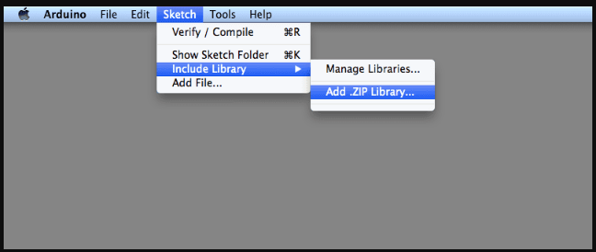

Manual installation of Library files in Arduino IDE:
When want to add a library manually, we need to download it as a ZIP file, expand it and put in the proper directory. The ZIP file contains all you need, including usage examples if the author has provided them. The library manager is designed to install this ZIP file automatically as explained in the former chapter, but there are cases where you may want to perform the installation process manually and put the library in the libraries folder of sketchbook.
We can find or change the location of your sketchbook folder at File > Preferences > Sketchbook location.

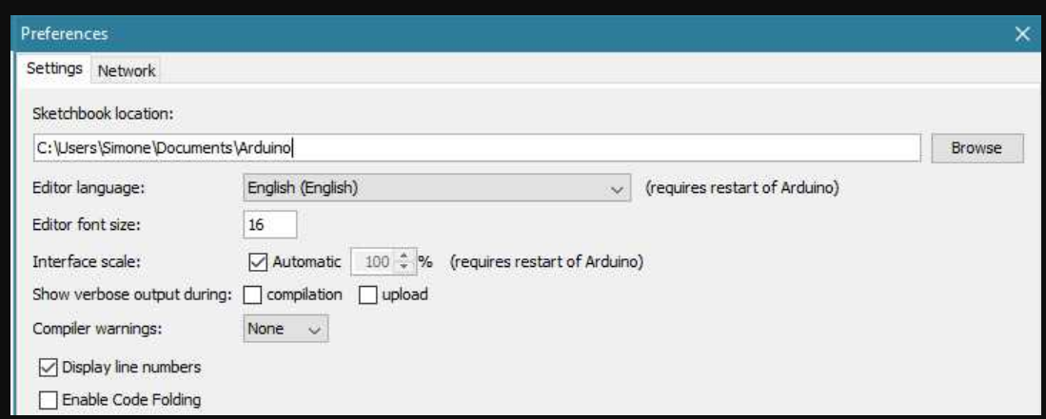

The same happens for the libraries present in additional cores installations. It is also important to note that the version of the library you put in your sketchbook may be lower than the one in the distribution or core folders, nevertheless it will be the one used during compilation. When you select a specific core for your board, the libraries present in the core's folder are used instead of the same libraries present in the IDE distribution folder.
Last, but not least important is the way the Arduino Software (IDE) upgrades itself: all the files in Programs/Arduino (or the folder where you installed the IDE) are deleted and a new folder is created with fresh content. This is why we recommend that you only install libraries to the sketchbook folder so they are not deleted during the Arduino IDE update process.
Go to the directory where you have downloaded the ZIP file of the library.
Extract the ZIP file with all its folder structure in a temporary folder, then select the main folder, that should have the library name. Copy it in the "libraries" folder inside your sketchbook. Start the Arduino Software (IDE), go to Sketch > Include Library. Verify that the library we just added is available in the list.

The same happens for the libraries present in additional cores installations. It is also important to note that the version of the library you put in your sketchbook may be lower than the one in the distribution or core folders, nevertheless it will be the one used during compilation. When you select a specific core for your board, the libraries present in the core's folder are used instead of the same libraries present in the IDE distribution folder.
Arduino libraries are managed in three different places: inside the IDE installation folder, inside the core folder and in the libraries folder inside your sketchbook. The way libraries are chosen during compilation is designed to allow the update of libraries present in the distribution. This means that placing a library in the "libraries" folder in your sketchbook overrides the other libraries versions.
Serial Monitor of Arduino IDE:

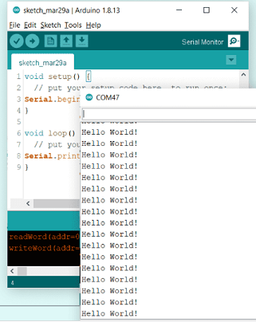

The Arduino IDE has the Serial Monitor tool integrated with the editor, which means that no external window is opened when using the Serial Monitor. This means that you can have multiple windows open, each with its own Serial Monitor.
This displays serial sent from the Arduino board over USB or serial connector. To send data to the board, enter text and click on the "send" button or press enter. Choose the baud rate from the drop-down menu that matches the rate passed to Serial. Begin in your sketch. Note that on Windows, Mac or Linux the board will reset (it will rerun your sketch) when you connect with the serial monitor. Please note that the Serial Monitor does not process control characters; if your sketch needs a complete management of the serial communication with control characters, you can use an external terminal program and connect it to the COM port assigned to your Arduino board.

Boards selection for Arduino IDE:
The board selection has two effects: it sets the parameters (e.g. CPU speed and baud rate) used when compiling and uploading sketches; and sets and the file and fuse settings used by the burn bootloader command. Some of the board definitions differ only in the latter, so even if you've been uploading successfully with a particular selection, you'll want to check it before burning the bootloader.
Arduino Software (IDE) includes the built-in support for the boards in the following list, all based on the AVR Core. The Boards Manager included in the standard installation allows to add support for the growing number of new boards based on different cores like Arduino Due, Arduino Zero, Edison, Galileo and so on.
- Arduino Yún An ATmega32u4 running at 16 MHz with auto-reset, 12 Analog In, 20 Digital I/O and 7 PWM.
- Arduino Uno An ATmega328P running at 16 MHz with auto-reset, 6 Analog In, 14 Digital I/O and 6 PWM.
- Arduino Diecimila or Duemilanove w/ ATmega168 An ATmega168 running at 16 MHz with auto-reset.
- Arduino Nano w/ ATmega328P An ATmega328P running at 16 MHz with auto-reset. Has eight analog inputs.
- Arduino Mega 2560 An ATmega2560 running at 16 MHz with auto-reset, 16 Analog In, 54 Digital I/O and 15 PWM.
- Arduino Mega an ATmega1280 running at 16 MHz with auto-reset, 16 Analog In, 54 Digital I/O and 15 PWM.
- Arduino Mega ADK An ATmega2560 running at 16 MHz with auto-reset, 16 Analog In, 54 Digital I/O and 15 PWM.
- Arduino Leonardo An ATmega32u4 running at 16 MHz with auto-reset, 12 Analog In, 20 Digital I/O and 7 PWM.
- Arduino Micro an ATmega32u4 running at 16 MHz with auto-reset, 12 Analog In, 20 Digital I/O and 7 PWM.
- Arduino Esplora An ATmega32u4 running at 16 MHz with auto-reset.
- Arduino Mini w/ ATmega328P An ATmega328P running at 16 MHz with auto-reset, 8 Analog In, 14 Digital I/O and 6 PWM.
- Arduino Ethernet Equivalent to Arduino UNO with an Ethernet shield: An ATmega328P running at 16 MHz with auto-reset, 6 Analog In, 14 Digital I/O and 6 PWM.
- Arduino Fio An ATmega328P running at 8 MHz with auto-reset. Equivalent to Arduino Pro or Pro Mini (3.3V, 8 MHz) w/ ATmega328P, 6 Analog In, 14 Digital I/O and 6 PWM.
- Arduino BT w/ ATmega328P ATmega328P running at 16MHz. The bootloader burned (4 KB) includes codes to initialize the on-board Bluetooth® module, 6 Analog In, 14 Digital I/O and 6 PWM.
- LilyPad Arduino USB An ATmega32u4 running at 8 MHz with auto-reset, 4 Analog In, 9 Digital I/O and 4 PWM.
- LilyPad Arduino An ATmega168 or ATmega132 running at 8 MHz with auto-reset, 6 Analog In, 14 Digital I/O and 6 PWM.
- Arduino Pro or Pro Mini (5V, 16 MHz) w/ ATmega328P An ATmega328P running at 16 MHz with auto-reset. Equivalent to Arduino Duemilanove or Nano w/ ATmega328P; 6 Analog In, 14 Digital I/O and 6 PWM.
- Arduino NG or older w/ ATmega168 An ATmega168 running at 16 MHz without auto-reset. Compilation and upload are equivalent to Arduino Diecimila or Duemilanove w/ ATmega168, but the bootloader burned has a slower timeout (and blinks the pin 13 LED three times on reset); 6 Analog In, 14 Digital I/O and 6 PWM.
- Arduino Robot Control an ATmega328P running at 16 MHz with auto-reset.
- Arduino Robot Motor an ATmega328P running at 16 MHz with auto-reset.
- Arduino Gemma An ATtiny85 running at 8 MHz with auto-reset, 1 Analog In, 3 Digital I/O and 2 PWM.

Advantages of Arduino IDE:
- Easy to Use. Arduino is super easy to learn.
- Inexpensive Hardware. Arduino boards are available at low cost.
- Active User Community.
- Cross Platform Support.
- Tons of Libraries.
- Lack of Multitasking.
- Not Optimized for Performance.
- Lack of Communications.

Embedded C:
Embedded C is most popular programming language in software field for developing electronic gadgets. Each processor used in electronic system is associated with embedded software. Embedded C programming plays a key role in performing specific function by the processor. This text is designed to introduce and expand upon material related to the C programming language and embedded controllers, and specifically, the Arduino development system and associated Atmel ATmega microcontrollers. It is intended to fit the time constraints of a typical 3 to 4 credit hour course for electrical engineering technology and computer engineering technology programs, although it could also fit the needs of a hardware-oriented course in computer science. As such, the text does not attempt to cover every aspect of the C language, the Arduino system or Atmel AVR microcontrollers. The first section deals with the C language itself. It is assumed that the student is a relative newcomer to the C language but has some experience with another high-level language, for example, Python. This means concepts such as conditionals and iteration are already familiar and the student can get up and running fairly quickly. From there, the Arduino development environment is examined. This course introduces the C programming language and specifically addresses the issue of embedded programming. It is assumed that you have worked with some other high-level language before, such as Python, BASIC, FORTRAN or Pascal. Due to the complexities of embedded systems, we begin with a typical desktop system and examine the structure of the language along with basic examples. Once we have a decent grounding in syntax, structure, and the development cycle, we switch over to an embedded system, namely an Arduino based development system. This course is designed so that you can do considerable work at home with minimal cost if you choose to (this is entirely optional, but programming these little beasties can be addicting so be forewarned). Along with this course text and the associated lab manual, you will need an Arduino Uno board (about $25) and a USB host cable. A small “wall wart” power adapter for it may also be useful. There’s a lot of free C programming info on the Internet but if you prefer print books and want more detail, you may also wish to purchase one of the many C programming texts available. Two good titles are Kochan’s book Programming in C and the one by Deitel & Deitel, C-How to Program. Whichever book you choose, make sure that its focus is C and not C++. You will also need a desktop C compiler. Just about any will do, including Visual C/C++, Borland, CodeWarrior, or even GCC. A couple of decent freeware compilers available on the Internet include Pelles C and Miracle C.
C is perhaps the most widely used development language today. That alone is a good reason to consider it but there’s more: It is a modern structured language that has been standardized (ANSI). It is modular, allowing reuse of code. It is widely supported, allowing source code to be used for several different platforms by just recompiling for the new target. Its popularity means that several third-party add-ons (libraries and modules) are available to “stretch” the language. It has type checking which helps catch errors. It is very powerful, allowing you to get “close to the metal”. Generally, it creates very efficient code (small space and fast execution).
C++ is a superset of C. First came C, then came C++. In fact, the name C++ is a programmer’s joke because ++ is the increment operator in C. Thus, C++ literally means “increment C”, or perhaps “give me the next C”. C++ does everything C does plus a whole lot more. These extra features don’t come free and embedded applications usually cannot afford the overhead. Consequently, although much 8 Embedded Controllers desktop work is done in C++ as well as C, most embedded work is done in C. Desktop development systems are usually referred to as C/C++ systems meaning that they’ll do both. Embedded development systems may be strictly C or even a variant of it.

Desktop development focuses on applications for desktop computers. These include things like word processors, graphing utilities, games, CAD programs, etc. These are the things most people think of when they hear the word “computer”. Embedded programming focuses on the myriad nearly invisible applications that surround us every day. Examples include the code that runs your microwave oven, automobile engine management system, cell phone, and many others. In terms of total units, embedded applications far outnumber desktop applications. You may have one or even a few PCs in your house but you probably use dozens of embedded applications every day. Embedded microcontrollers tend to be much less powerful but also much less expensive than their PC counterparts. The differing programming techniques are an integral part of this course and we shall spend considerable time examining them.

In day-to-day life we used many electronic devices such as mobile phone, washing machine, digital camera, etc. These all-device working is based on microcontroller that are programmed by embedded C.

Embedded Software or Program allow Hardware to monitor external events (Inputs / Sensors) and control external devices (Outputs) accordingly. During this process, the program for an Embedded System may have to directly manipulate the internal architecture of the Embedded Hardware (usually the processor) such as Timers, Serial Communications Interface, Interrupt Handling, and I/O Ports etc.

An Embedded System is a system that has software embedded into computer-hardware, which makes a system dedicated for a variety of application or specific part of an application or product or part of a larger system.
An embedded system can be a small independent system or a large combinational system. It is a microcontroller-based control system used to perform a specific task of operation.
An embedded system is a combination of three major components:
- Hardware:
Hardware is physically used component that is physically connected with an embedded system. It comprises of microcontroller based integrated circuit, power supply, LCD display etc.
- Application software:
Application software allows the user to perform varieties of application to be run on an embedded system by changing the code installed in an embedded system.
- Real Time Operating system (RTOS):
RTOS supervises the way an embedded system work. It acts as an interface between hardware and application software which supervises the application software and provide mechanism to let the processor run on the basis of scheduling for controlling the effect of latencies.

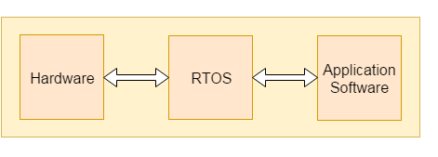

Designing of an embedded system:
The basic structure of an embedded system is as shown in below figure.

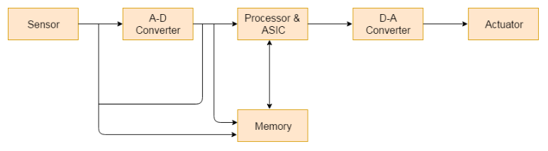
Fig 1: Designing of an Embedded System

Sensor:
Sensor used for sensing the change in environment condition and it generate the electric signal on the basis of change in environment condition. Therefore, it is also called as transducers for providing electric input signal on the basis of change in environment condition.

A-D Converter:
An analog-to-digital converter is a device that converts analog electric input signal into its equivalent digital signal for further processing in an embedded system.
Processor & ASICs:
Processor used for processing the signal and data to execute desired set of instructions with high-speed of operation. Application specific integrated circuit (ASIC) is an integrated circuit designed to perform task specific operation inside an embedded system.
D-A Converter:
A digital-to-analog converter is a device that converts digital electric input signal into its equivalent analog signal for further processing in an embedded system.
Actuators:
Actuators is a comparator used for comparing the analog input signal level to desired output signal level for providing the error free output from the system.

Design steps for the development of Embedded System:
- Designing steps required for embedded system are different from the design process of another electronic system.
- The flow chart represents the design steps required in the development of an embedded system:

Fig 2: Flow chart of development of Embedded system

Embedded System processors:
Processors are the major part in embedded systems that take response from sensors in digital form and processing of this response to produce output in real-time processing environment is performed using processors. For an embedded system developer, it is essential to have the knowledge of both microprocessors and micro controllers.

Processors inside a system:
Processors inside a system have two essential units:

Control unit:
This unit in processors performed the program flow control operation inside an embedded system. The control unit also acts as a fetching unit for fetching the set of instructions stored inside a memory.
Execution unit:
This unit is used for execution the various tasks inside a processor. It mainly comprises of arithmetic and logical unit (ALU) and it also include a circuit that executes the instruction sets used to perform program control operation inside processors.

Types of processors:
Processors inside an embedded system are of the following categories:
- Application Specific System Processor (ASSP): ASSP is application dependent system processor used for processing signal of embedded system. Therefore, for different application performing task a unique set of system processors is required.
- Application Specific Instruction Processor (ASIP): ASIP is application dependent instruction processors. It is used for processing the various instruction set inside a combinational circuit of an embedded system.
- General Purpose Processor (GPP): GPP is used for processing signal from input to output by controlling the operation of system bus, address bus and data bus inside an embedded system.

Types of general-purpose processor are:
- Microprocessor
- Microcontroller
- Digital signal processor
- Analog signal processor

Embedded System Tools:
Compiler:
Compiler is used for converting the source code from a high-level programming language to a low-level programming language. It converts the code written in high level programming language into assembly or machine code. The main reason for conversion is to develop an executable program.
Let's see the operations performed by compiler are:
- Code generation
- Code optimization
- Parsing
- Syntax direct translation
- Preprocessing
Decompiler:
A tool used for translating a program from a low-level language to high-level language is called a decompiler. It is used for conversion of assembly or machine code to high-level programming language.
Assembler:
Assembler is embedded system tool used for translating a computer instruction written in assembly language into a pattern of bits which is used by the computer processor for performing its basic operations. Assembler creates an object code by translating assembly language instruction into set of mnemonics for representing each low-level machine operation.
Debugging:
Debugging is a tool used for reducing the number of error or bugs inside a computer program or an assembled electronic hardware. Debugging of a compact subsystem is difficult because a small change in one subsystem can create bugs in another system. The debugging used inside embedded system differs in terms of their development time and debugging features.
Simulators:
Simulator is a tool used for simulation of an embedded system. Code tested for microcontroller unit by simulating code on the host computer. Simulator is used for model the behaviour of the complete microcontroller in software.

CHAPTER-3(EXISTING and PROPOSED METHOD):
Existing System
In the existing agricultural systems, most farmers still rely on manual methods to monitor soil conditions, temperature, humidity, and water levels. They decide when to water crops based on personal experience or visual observation, which often leads to over-irrigation or under-irrigation. This not only causes water wastage but also affects soil health, crop quality, and yield.
Some farms use basic sensor systems that measure parameters such as soil moisture or temperature, but these systems usually operate independently and do not share data over the internet. They lack real-time monitoring, automatic control, and data analytics capabilities. In most cases, farmers must physically check the sensors in the field to understand the readings, which is time-consuming and inefficient.
Moreover, existing systems rarely use Machine Learning (ML) techniques. As a result, they cannot make intelligent predictions or provide insights based on historical data. This prevents farmers from getting accurate recommendations regarding irrigation scheduling, soil health trends, or environmental variations.
Overall, the existing system is less efficient, time-consuming, and not data-driven, making it difficult for farmers to adopt sustainable and smart agricultural practices.

Proposed System
The proposed system introduces a Smart Agriculture Monitoring Kit that combines Internet of Things (IoT) and Machine Learning (ML) technologies to make farming more efficient, automated, and intelligent. The system is developed using an ESP32 microcontroller integrated with soil moisture, temperature, humidity, and water level sensors. These sensors continuously collect real-time environmental data from the field.
The ESP32 processes this data and transmits it via Wi-Fi to a cloud platform or mobile application for remote monitoring. Farmers and engineers can easily view live data on soil moisture, temperature, humidity, and water level from anywhere, enabling timely and informed decisions.
Using Machine Learning algorithms, the system analyzes historical data to:
- Predict optimal irrigation timing,
- Detect unusual temperature or humidity fluctuations, and
- Identify low water levels or soil dryness conditions.
The ML model learns from previous data patterns and provides intelligent recommendations to optimize resource use and improve crop growth.
This proposed system significantly reduces manual effort, saves water, and enhances productivity through data-driven insights. It also serves as a learning and experimental platform for students and engineers to understand IoT and ML applications in agriculture.
The smart agricultural kit is cost-effective, scalable, and user-friendly, making it suitable for small farms, research projects, and educational purposes.
Block Diagram:
ML

Esp32
WIFI
humidity

Water level sensor
Moisture sensor
Temperature sensor

Power Supply

Software Requirements:
  - Arduino IDE
  - Embedded C
  - Machine learning

Hardware Requirements:
- Esp32 microcontroller
- Power Supply
- Temperature sensor
- Moisture sensor
- Water level sensor

1. ESP32 Microcontroller
The ESP32 is a powerful microcontroller with built-in Wi-Fi and Bluetooth capabilities.It is widely used for IoT (Internet of Things) applications and wireless communication.
The ESP32 has a dual-core processor, which allows multitasking and faster processing.It supports both analog and digital inputs/outputs, making it compatible with many sensors.
It operates at 3.3V, and can be programmed using the Arduino IDE or other platforms.The board includes multiple GPIO pins, PWM, ADC, and I2C interfaces.It can connect to cloud servers or mobile apps for data sharing.
Its low power consumption makes it ideal for battery-operated devices.
It has built-in memory and flash storage for running complex programs.
The ESP32 is popular among engineers for automation, monitoring, and control systems.
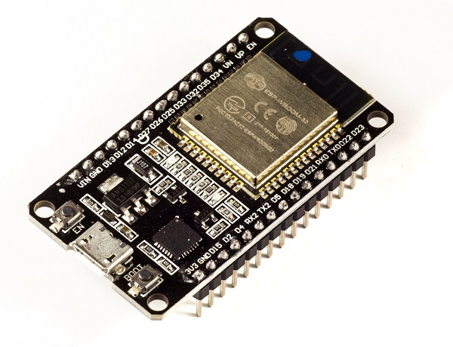
2. Power Supply
A power supply is an essential component that provides electrical energy to all electronic circuits.
It converts AC (Alternating Current) from mains into DC (Direct Current) for electronic devices.
The output voltage and current depend on the circuit’s requirement.
Common DC supply levels are 3.3V, 5V, and 12V for microcontrollers and sensors.It can be obtained using batteries, USB ports, or adapter modules.
Power supplies may include voltage regulators to maintain stable output.
They protect the components from voltage fluctuations and overloads.
Different types include linear, switching, and regulated power supplies.
An efficient power supply improves system performance and reliability.
It is a basic and essential element in all electronic and embedded systems.

3. Temperature Sensor
A temperature sensor is a device that measures the degree of heat or cold in an environment.
It converts temperature changes into electrical signals.
Common types include thermistors, thermocouples, and semiconductor sensors.It helps in maintaining optimal temperature in various applications.
The sensor output can be analog or digital, depending on the model.
Digital sensors provide accurate readings and easy interfacing with microcontrollers.Temperature sensors are used in industrial, automotive, and household systems.
They are essential in systems like HVAC, refrigeration, and environmental monitoring.The accuracy and range depend on the sensor’s design and material.These sensors are simple, reliable, and easy to integrate into electronic circuits.
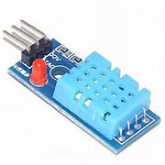
4. Moisture Sensor
A moisture sensor is used to detect the amount of water present in a medium, such as soil or material.
It operates by measuring electrical resistance or capacitance changes caused by moisture.The sensor provides data in the form of analog or digital signals.Moisture sensors help in determining when water is needed in various processes.They are commonly used in agriculture, food storage, and environmental studies.The sensor has two probes that are inserted into the medium to sense water content.High moisture results in lower resistance, while dry conditions increase it.
The data from the sensor can be processed to control irrigation or drying systems.It is compact, low-cost, and consumes very little power.
These sensors are useful for both automation and research applications.
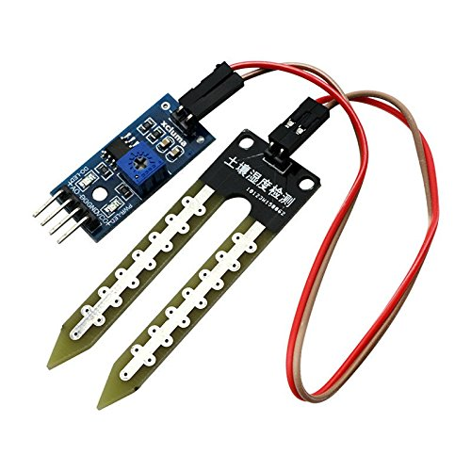
5. Water Level Sensor
A water level sensor detects and measures the level of water in a container, tank,orsurface.It works using conductivity, pressure, or ultrasonic principles.The sensor can provide digital or analog output depending on its type.It is used in systems like tanks, reservoirs, and water treatment plants.The sensor helps prevent overflow or dry running of pumps.
Some sensors have multiple detection points for different water levels.
They are durable and can function in both clean and dirty water.
The device is easy to install and requires low maintenance.
Water level sensors are vital for automation and fluid control systems.
They ensure efficient water management in both domestic and industrial applications.
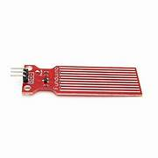

Methodology
The proposed system follows a systematic process to collect, analyze, and display agricultural data using IoT and Machine Learning (ML). The ESP32 microcontroller acts as the central control unit, interfacing with various sensors such as the soil moisture sensor, temperature sensor, humidity sensor, and water level sensor. Each of these sensors measures real-time environmental parameters like soil moisture, temperature, humidity, and water level.
The ESP32 collects the sensor readings and processes them to filter out unwanted noise or errors. Using its built-in Wi-Fi module, the processed data is transmitted to a cloud platform or mobile application, allowing remote monitoring and real-time visualization. Users can easily access live updates and track the field’s conditions through a user-friendly interface.
The Machine Learning model plays a crucial role in intelligent data analysis. It is trained using historical sensor data to recognize patterns and correlations between soil and environmental conditions. Based on this learned information, the model can predict irrigation requirements, detect abnormal temperature or humidity changes, and suggest optimal watering schedules. This ensures efficient water management and helps in maintaining favorable conditions for crop growth.
Finally, the system provides both real-time and predicted data to the user in an easy-to-understand format. The overall methodology integrates IoT for data collection and ML for smart decision-making, resulting in a reliable, intelligent, and efficient solution for modern agriculture.

Advantages
- Provides real-time monitoring of soil moisture, temperature, humidity, and water levels.
- Uses Machine Learning to predict irrigation needs accurately.
- Saves water and energy through intelligent automation and data-based control.
- Enables remote monitoring via mobile or cloud platforms.
- Reduces manual labor and minimizes human error in traditional farming methods.
- Improves crop yield and soil health through optimized irrigation practices.
- Low-cost and easy-to-install system suitable for both small and large farms.
- Promotes sustainable agriculture by conserving resources effectively.
- Serves as an educational tool for students and engineers interested in IoT and ML.
- Can be upgraded with additional sensors and smart features for future expansion.

Applications
- Smart farming for real-time monitoring of soil and environmental conditions.
- Automated irrigation management to optimize water usage.
- Greenhouse monitoring to maintain suitable growing conditions.
- Agricultural research for analyzing soil and crop growth patterns.
- Nursery and garden automation for plant health maintenance.
- Remote and rural farm monitoring where manual observation is difficult.
- Precision agriculture systems for high-efficiency crop management.
- Water management in tanks, reservoirs, and irrigation channels.
- Educational institutions for IoT and ML-based project learning.
- Environmental monitoring systems for sustainability studies.

Limitations
- Depends on a stable internet connection for continuous data transmission.
- Sensor accuracy can be influenced by dust, humidity, or environmental factors.
- Requires periodic maintenance and calibration of sensors.
- Initial setup may require basic technical knowledge of IoT and ML.
- Power supply interruptions may disrupt data collection.
- ML models need sufficient datasets for reliable prediction accuracy.
- Wi-Fi connectivity range is limited in large farm areas.
- Environmental factors can cause slight data fluctuations.
- Some sensors may not be fully weatherproof without protective casing.
- Cost may increase with the addition of advanced sensors or modules.

CHAPTER-4(RESULTS AND CONCLUSION):
Result
The developed system successfully collected real-time data from the soil moisture sensor, temperature sensor, humidity sensor, and water level sensor using the ESP32 microcontroller. The data was transmitted to a cloud platform via Wi-Fi for remote monitoring and analysis.
The Machine Learning model effectively analyzed the collected data and accurately predicted irrigation requirements and environmental variations. The results confirmed that the system can efficiently monitor soil, humidity, and water conditions, helping farmers plan irrigation schedules more accurately.
Overall, the system proved to be reliable, efficient, and user-friendly, providing a valuable platform for agricultural monitoring, learning, and research purposes.

Conclusion
The project demonstrates that the integration of IoT and Machine Learning can significantly improve agricultural practices by enabling intelligent, data-driven decision-making. By using sensors and wireless data transmission, farmers and engineers can easily monitor environmental parameters such as soil moisture, temperature, humidity, and water levels in real time.
The system reduces manual effort, conserves water, and promotes sustainable farming by automating the monitoring process and offering predictive insights. It also serves as an educational tool for students and engineers, enhancing understanding of smart technologies and their applications in agriculture.
In conclusion, this project shows how the combination of IoT and ML can modernize traditional farming, improve crop productivity, and provide a cost-effective solution for precision agriculture.

Future Scope
The system has great potential for further enhancement. In the future, it can be upgraded with:
- Additional sensors such as pH, nutrient, or rainfall sensors for advanced soil and environmental analysis.
- Automatic irrigation control that activates water pumps based on predicted soil moisture levels.
- Improved ML models using larger datasets and cloud-based AI platforms for higher prediction accuracy.
- Mobile notifications and voice assistant integration for better user interaction.
- Solar-powered operation to increase energy efficiency and make the system suitable for remote rural areas.
With these advancements, the system can evolve into a fully automated smart farming solution, contributing significantly to sustainable and precision agriculture.

References
- De Clercq, M., Vats, A., & Biel, A. (2018). Agriculture 4.0: The Future of Farming Technology. Proceedings of the World Government Summit, Dubai, UAE, 1113.
- Charvat, K., Gnip, P., Vohnout, P., & Charvat Jr, K. (2011). Vision for a Farm of Tomorrow. IST Africa.
- Tilman, D., Balzer, C., Hill, J., & Befort, B. L. (2011). Global Food Demand and the Sustainable Intensification of Agriculture. Proceedings of the National Academy of Sciences, 108(50), 20260–20264.
- Weltzien, C. (2016). Digital Agriculture or Why Agriculture 4.0 Still Offers Only Modest Returns. Landtechnik, 71(2), 66–68.
- Bovensiepen, G., & Hombach, R. (2016). Quo Vadis, Agricola? Smart Farming: Nachhaltigkeit und Effizienz durch den Einsatz digitaler Technologien. PwC.
- Kamilaris, A., Kartakoullis, A., & Prenafeta-Boldú, F. X. (2017). A Review on the Practice of Big Data Analysis in Agriculture. Computers and Electronics in Agriculture, 143, 23–37.
- Auernhammer, H. (2001). Precision Farming — The Environmental Challenge. Computers and Electronics in Agriculture, 30(1–3), 31–43.
- Lal, R., & Stewart, B. A. (Eds.). (2015). Soil-Specific Farming: Precision Agriculture (Vol. 22). CRC Press.

